# **SVN NOTES**

A VCS is divided into two categories.

* **Centralized Version Control System (CVCS), and**
* **Distributed/Decentralized Version Control System (DVCS).**

Subversion falls under **centralized version control system**, meaning that it uses central server to store all files and enables team collaboration.

The usual solution is to have the following top-level directories:

**Subversion usually uses structure with 3 folders:**

**trunk:** contains latest source code, which is on development like master

**tags:** contains snapshot of project. For example: Project A releases version 1.0, all sources inside trunk will be tagged into 1.0 tag, and later, when we need to build/deploy or review version 1.0 again, we will get the tag 1.0

**branches:** contains different branches of project. Developers can work on multiple, simultaneous features without affecting others. Branches can be merged later after feature has been implemented

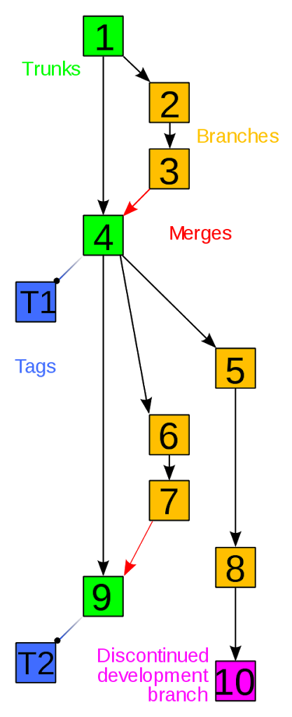

The photo above represents development status of a repository, with several actions within Version Control System.

* Trunk folder of repository
* From trunk folder, create new branch for development
* Work with new branch
* After new branch had completed its own feature, merge it with main branch. Project is stable now and will be tagged as T1
* Continue to develop
* Continue to develop
* New branch is created
* New branch is created
* New branch is completed, merge it onto main branch
* This branch is discontinued, development is no longer active

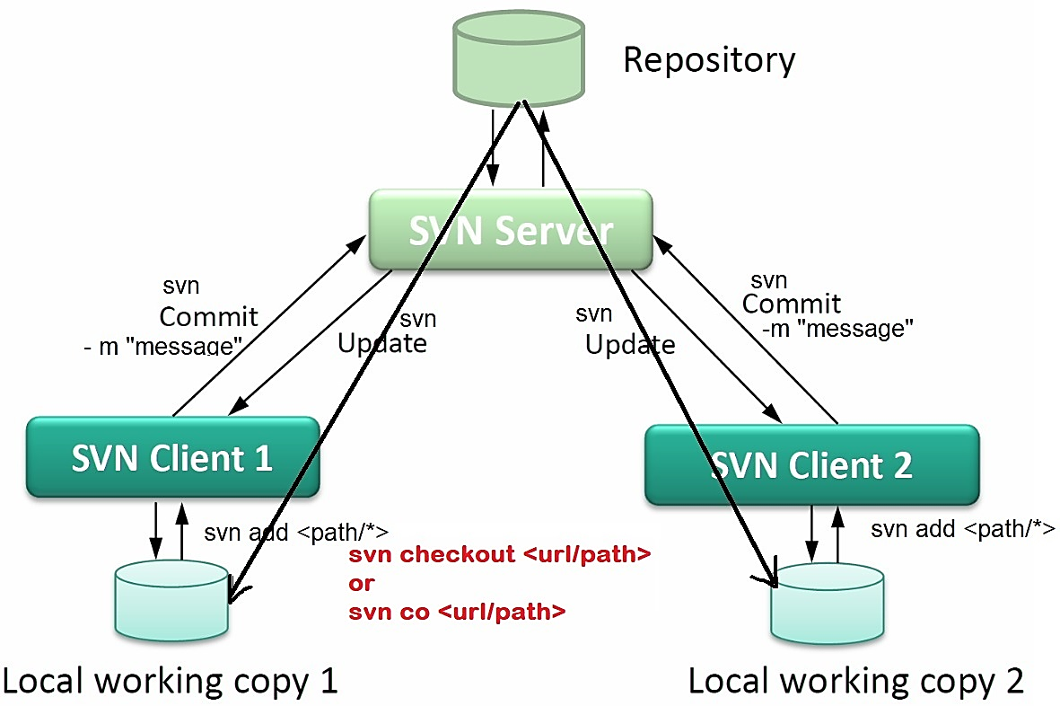

**SVN Checkout Command**

The svn checkout command is used to create the working copy of the SVN project.

**svn checkout URL Path**

Or

**svn co URL Path**

EX: svn co https://www.thegeekstuff.com/project/branches/release/migration/data/cfg /home/sasikala/cfg/

This is like git clone

**SVN Add Command**

The svn add command is used to add the files in the repository for the SVN. Whenever we create a new file in our working copy, we have to send it to the SVN server.

## Add specific folder/file

**svn add <folder/file>**

## Add all items in

**svn add \***

**SVN Delete Command**

The svn delete command is used to remove the files from the repository. When we perform a delete operation, it removes the file from the working. To delete it from the repository, run a commit command after the delete command.

## Delete from local

**svn delete <filename>**

##To remove it from the repository

**svn, commit -m "type your message."**

**SVN Diff Command**

The svn diff command is used to display the differences between two versions of files. We can find the differences between the working copy and the remote (SVN) copy.

## See changes in file

**svn diff filename**

## Compare two files in r1 and r2 Revisons

**svn diff -r R1: R2 filename**

**SVN Update Command**

The update command is used to update the working copy of the project. It brings the changes from the working copy to the repository.

## Update working copy from repo

**svn update <Path >**

**## View Conflicts**

**svn up**

**df -- Diff-full**

**p -- postpone**

**## TO know the status**

**svn status**

few status codes

A -- Addition, D -- Deletion, M -- Modified, R -- Replaced, C -- conflicts, I -- Ignored,

? -- Not in repo

**##Resolve Conflicts**

**svn resolve --accept=working <filename>**

**## Add branch**

**svn copy trunk/** branches**/<newbranch>**

Ex: svn copy trunk/ branches/jerry_branch

## ADD TAGS

**svn copy trunk/ tags/<name of tag>**

Ex: svn copy trunk/ tags/jerry_branch

## To get logs

**svn log**

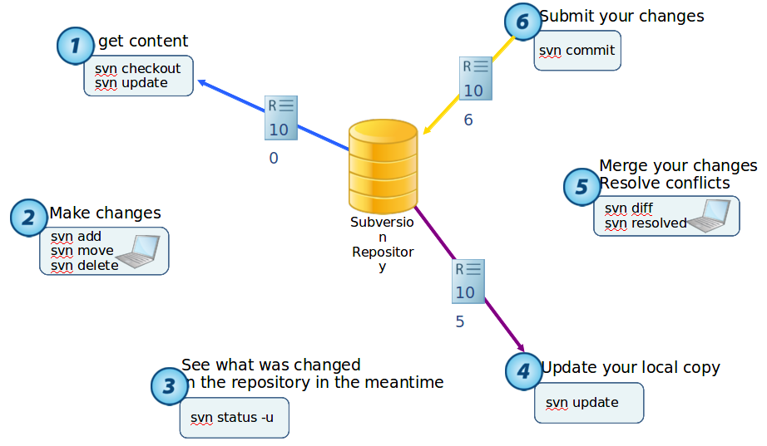

<https://cheatography.com/davechild/cheat-sheets/subversion/>